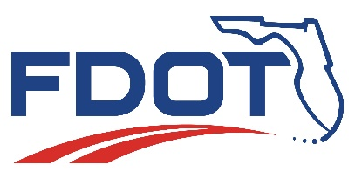
Florida Department of Transportation
RON DESANTIS  GOVERNOR | 1000 N.W. 111 Avenue  Miami, Florida 33172 | JARED W. PERDUE, P.E.  SECRETARY

For Immediate Release  May 4, 2022 | Contact: Tish Burgher  (305) 470-5277 | Tish.Burgher@dot.state.fl.us
State Road (SR) 916/NW 135 Street Pedestrian Safety Project Begins May 9
From Cairo Lane to Sesame Street

MIAMI, Fla. – The Florida Department of Transportation (FDOT) is scheduled to begin a pedestrian safety project the week of Monday, May 9, 2022, along SR 916/NW 135 Street from Cairo Lane to Sesame Street. The work will last roughly four months and will cost an estimated $284,703.

The scope of work includes: constructing a midblock pedestrian crosswalk and raised traffic separator; installing a new pedestrian traffic signal mast arm and new pedestrian poles; reconstructing concrete sidewalks; installing new signage and pavement markings; and repaving and restriping the roadway.

To build this project safely, it will be necessary to close travel lanes, sidewalks and establish detours at times. Work will be done in stages to minimize construction related impacts. Drivers might experience delays traveling through the area and should seek alternate routes if possible. Please use caution when traveling through construction zones.

Please follow all posted signage and note that this schedule may change due to bad weather or other unexpected conditions.

For more information, please contact FDOT’s Public Information Office at (305) 470-5349, or Construction Community Outreach Specialist Christian Gonzalez at (786) 837-4884 or csgonzalez@corradino.com. For additional information about this or other FDOT projects, please visit www.fdotmiamidade.com.

Drivers are encouraged to log on to www.fl511.com before they travel to get real-time traffic and lane closure information. FDOT would like to remind drivers that wearing a safety belt is the single most effective way to protect people and reduce fatalities in motor vehicle crashes.

###

Improve Safety, Enhance Mobility, Inspire Innovation
FDOTMiamiDade.com | @MyFDOT_Miami | Facebook.com/MyFDOTMiami

The Florida Department of Transportation’s mission is to provide a safe transportation system that ensures the mobility of people and goods, enhances economic prosperity, and preserves the quality of the state’s environment and communities. The department is committed to building a transportation system that not only fits the current needs of Florida’s residents and visitors, but also enhances mobility throughout the state to accommodate its consistent and rapid growth. The unique nature of the Sunshine State and its year-round warm climate provides numerous opportunities to achieve the department’s mission through multiple transportation modes including highways/streets, air, rail, sea, spaceports, transit, and the ever-expanding deployment of bicycle & pedestrian facilities

