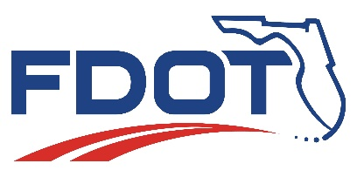
Florida Department of Transportation
RON DESANTIS  GOVERNOR |  | JARED W. PURDUE, P.E.  SECRETARY

For Immediate Release  January 27, 2023 | Contact: Tish Burgher  (305) 470-5277 | Tish.Burgher@dot.state.fl.us
FDOT State Road (SR) 826/Palmetto Expressway Capacity Project
Lane and Road Closures and Detours
Sunday, January 29 to Friday, February 3

MIAMI, Fla. – Drivers will experience road, lane and shoulder closures and detours on and near SR 826/Palmetto Expressway from Sunday, January 29, to Friday, February 3, 2023. The closures are necessary to allow for conducting drainage work and clean-up.

- Full closure of southbound entrance ramp to SR 826/Palmetto Expressway from SR 932/NW 103 Street/W 49 Street and NW 77 Avenue, 11 p.m. - 5 a.m., Sunday, January 29, through Thursday, February 2. See detour map #1 below.

- Full closure of NW 77 Avenue from NW 95 Street to NW 99 Street, 9 p.m. - 5 a.m., Sunday, January 29, through Thursday, February 2. See detour map #2 below.

- One lane closure on NW 77 Avenue from SR 25/US 27/Okeechobee Road to SR 932/NW 103 Street/W 49 Street, 9 p.m. - 6 a.m., Sunday, January 29.

- One lane closure and shoulder closures on NW 77 Avenue and W 20 Avenue from SR 25/US 27/Okeechobee Road to SR 932/NW 103 Street/W 49 Street, 9 p.m. - 6 a.m., Monday, January 30, through Thursday, February 2.

- One lane closure and shoulder closures on NW 77 Avenue and W 20 Avenue from SR 25/US 27/Okeechobee Road to NW 122 Street/W 68 Street, 9 a.m. - 6 p.m., Friday, February 3.

Please note that this schedule may change due to bad weather or other unforeseen conditions. Drivers should anticipate delays and seek alternate routes if possible.

The Palmetto Expressway Capacity Improvement Project includes modifying the southbound flyover from westbound NW 103 Street/W 49 Street to southbound SR 826 and widening the SR 826 bridge over NW 103 Street/W 49 Street to create an additional general-purpose lane. In addition, the express lane entrance at NW 154 Street/Miami Lakes Drive will be relocated to NW 103 Street/W 49 Street to allow access to the express lanes from NW 154 Street and NW 122 Street/W 68 Street. Construction began in April 2022 and will last about 30 months. This project will cost an estimated $66 million.

Drivers are encouraged to log on to www.fl511.com before they travel to get real-time traffic and lane closure information. The Florida Department of Transportation (FDOT) reminds motorists to always drive safely and avoid distractions while driving. Remember to put down cell phones. Florida law restricts motorists from using a wireless device in a school zone or an active construction zone.

For additional information, please call FDOT’s Public Information Office at (305) 470-5349 or contact Community Outreach Specialist Maria Camacho at (305) 731-7699 or Maria.Camacho@qcausa.com. You can also visit the project website at: www.826palmetto.com.

Detour Map #1

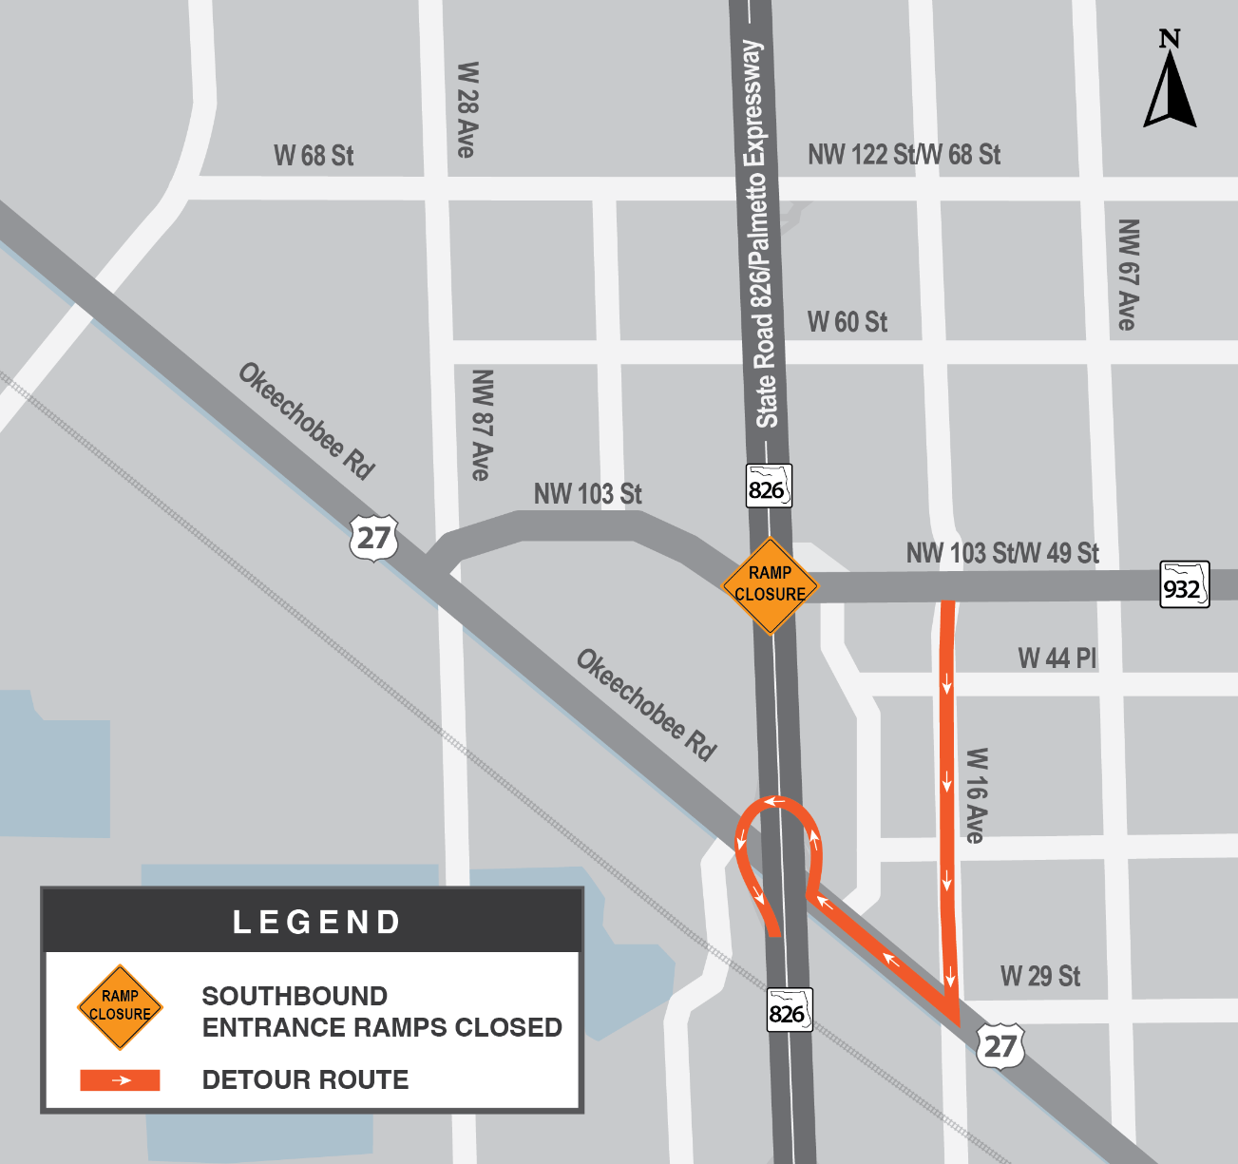

Detour Map #2
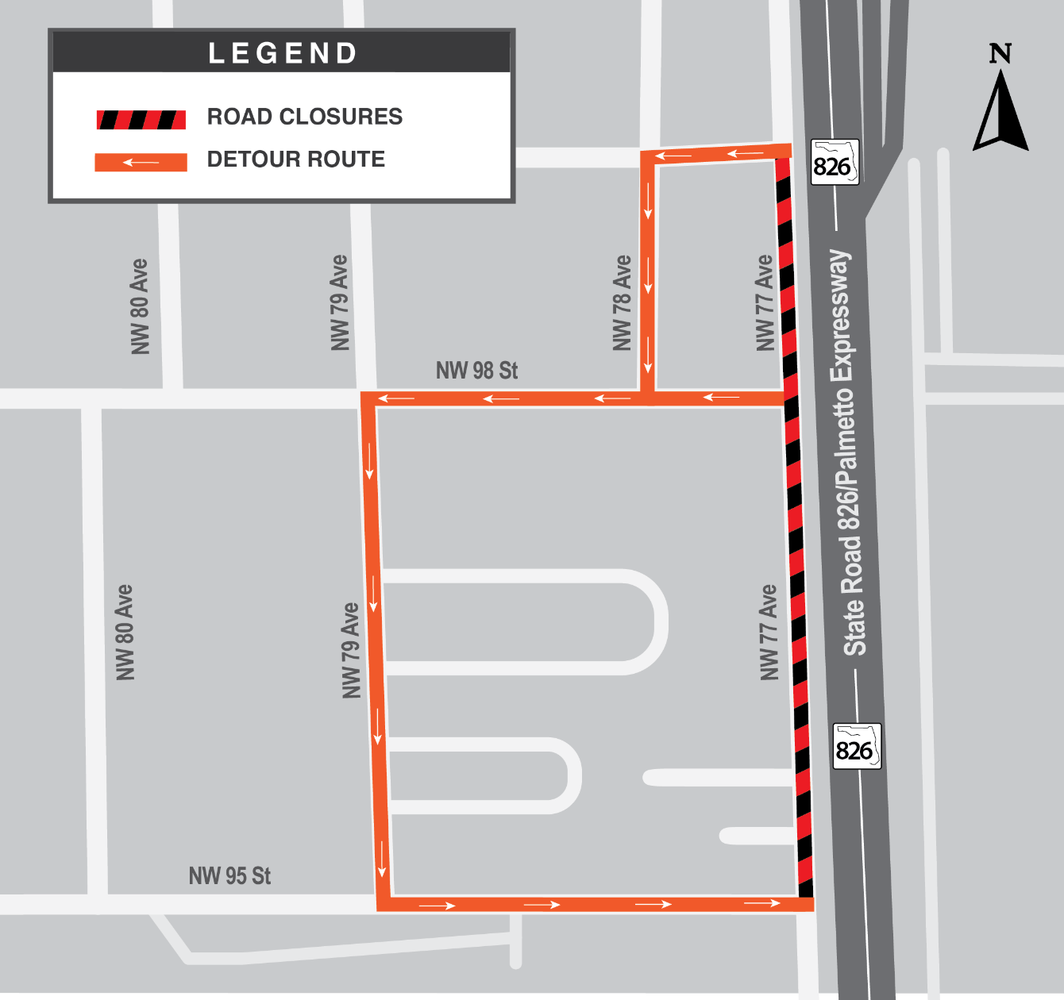
###

FDOTMiamiDade.com | @MyFDOT_Miami | Facebook.com/MyFDOTMiami

The Florida Department of Transportation’s mission is to provide a safe transportation system that ensures the mobility of people and goods, enhances economic prosperity, and preserves the quality of the state’s environment and communities. The department is committed to building a transportation system that not only fits the current needs of Florida’s residents and visitors, but also enhances mobility throughout the state to accommodate its consistent and rapid growth. The unique nature of the Sunshine State and its year-round warm climate provides numerous opportunities to achieve the department’s mission through multiple transportation modes including highways/streets, air, rail, sea, spaceports, transit, and the ever-expanding deployment of bicycle & pedestrian facilities.

