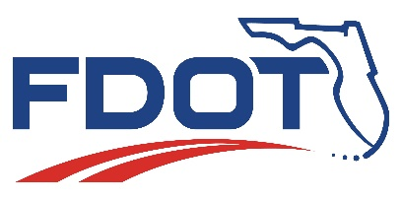
Florida Department of Transportation
RON DESANTIS  GOVERNOR | 1000 NW 111 Avenue  Miami, Florida 33172 | KEVIN J. THIBAULT, P.E.  SECRETARY

For Immediate Release  August 31, 2021 | Contact: Tish Burgher  (305) 470-5277 | Tish.Burgher@dot.state.fl.us
FDOT Hosts Multi-Agency Press Conference for Move Over Law, Announces Changes

MIAMI, Fla. – On Friday August 27, The Florida Department of Transportation (FDOT) hosted a multi-agency press conference urging motorists to follow the Move Over Law and announcing the recent amendment that covers additional service vehicles on the roadways. The event was followed by an enforcement detail led by Florida Highway Patrol (FHP) Troop E. A total of nine law enforcement agencies participated in this important safety event.

This enforcement operation yielded a total of seven arrests, 145 traffic citations, 12 written warnings, and participating law enforcement officers distributed 107 traffic safety educational materials.
FDOT District Six Secretary Stacy Miller said, “FDOT is committed to safety first and foremost. These events advance our agency’s mission of educating the public to improve safety, enhance mobility and provide transportation systems that are congestion and fatality free. We are grateful to our safety partners for helping us raise awareness for the Move Over Law.”

FHP Troop E, Lieutenant Alejandro Camacho said, “Along with FDOT, FHP’s top priority is safety. We applaud the positive results from this operation and are thankful to the law enforcement community for assisting us with this mission.”

To see event recap videos and photos, please click here. Motorists are encouraged to visit www.fl511.com before traveling to access real-time traffic information.

###

Improve Safety, Enhance Mobility, Inspire Innovation
www.fdot.gov | Twitter: @MyFDOT | Facebook: @FLDOT

The Florida Department of Transportation’s mission is to provide a safe transportation system that ensures the mobility of people and goods, enhances economic prosperity, and preserves the quality of the state’s environment and communities. The department is committed to building a transportation system that not only fits the current needs of Florida’s residents and visitors, but also enhances mobility throughout the state to accommodate its consistent and rapid growth. The unique nature of the Sunshine State and its year-round warm climate provides numerous opportunities to achieve the department’s mission through multiple transportation modes including highways/streets, air, rail, sea, spaceports, transit, and the ever-expanding deployment of bicycle & pedestrian facilities

