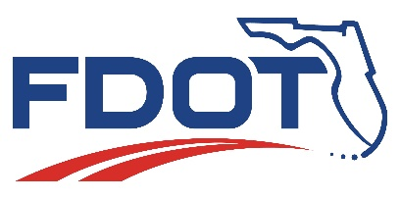
Florida Department of Transportation
RON DESANTIS  GOVERNOR | 1000 NW 111 Avenue  Miami, Florida 33172 | KEVIN J. THIBAULT, P.E.  SECRETARY

For Immediate Release  February 18, 2021 | Contact: Tish Burgher  (305) 470-5277 | Tish.Burgher@dot.state.fl.us

FDOT Announces Decision of Project Acceptance
State Road (SR) 826/Palmetto Expressway PD&E Study

MIAMI, Fla. – The Florida Department of Transportation (FDOT) granted Project Acceptance for the SR 826/Palmetto Expressway Project Development and Environment (PD&E) Study from south of NW 36 Street to north of NW 154 Street, in Miami-Dade County, on February 4, 2021. This project will now proceed to the next phase of development.
The proposed improvements consist of: increasing capacity and relieving congestion by converting a southbound express lane to a general purpose lane from north of NW 154 Street to north of NW 103 Street; widening the northbound mainline shoulder within the NW 103 Street interchange; modifying the bridge support of the NW 103 Street westbound flyover on-ramp; improving access into the express lane system by relocating the southbound entrance point further to the south; and extending the service life of the pavement, and improving geometry along, the frontage road system.
FDOT complied with state and federal laws and FDOT policy, including 23 U.S.C. Section 327 and a Memorandum of Understanding dated December 14, 2016, and executed by the Federal Highway Administration (FHWA).
For more information, please call FDOT’s Public Information Office at (305) 470-5349 or contact FDOT Project Manager Raul Quintela, P.E., at (305) 470-5271, Raul.Quintela@dot.state.fl.us. You may also visit www.fdotmiamidade.com/sr826north.

###

Improve Safety, Enhance Mobility, Inspire Innovation
FDOTMiamiDade.com | @MyFDOT_Miami | Facebook.com/MyFDOTMiami

The Florida Department of Transportation’s mission is to provide a safe transportation system that ensures the mobility of people and goods, enhances economic prosperity, and preserves the quality of the state’s environment and communities. The department is committed to building a transportation system that not only fits the current needs of Florida’s residents and visitors, but also enhances mobility throughout the state to accommodate its consistent and rapid growth. The unique nature of the Sunshine State and its year-round warm climate provides numerous opportunities to achieve the department’s mission through multiple transportation modes including highways/streets, air, rail, sea, spaceports, transit, and the ever-expanding deployment of bicycle & pedestrian facilities

